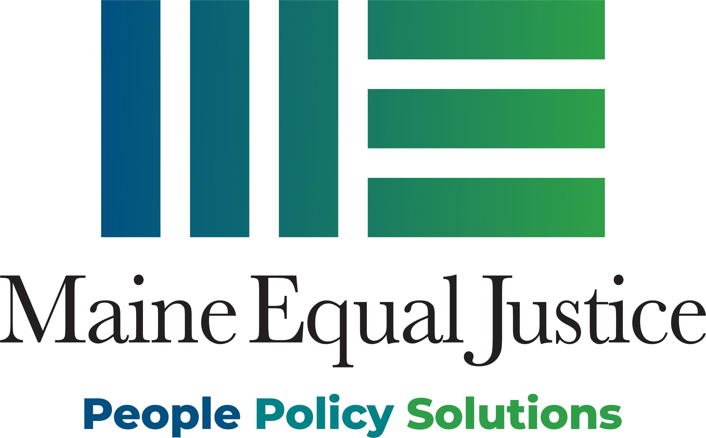

Thank you for your interest in scheduling a training session with Maine Equal Justice!

On what topic(s) are you requesting training?

* Food Supplement Benefits
* General Assistance
* Health Care
* Immigrant Access to Safety Net
* Advocacy 101
* Legislative Advocacy
* Legislative Update
* Safety Net Overview
* TANF/Aspire/PaS
* Other:

|  |  |  |
| --- | --- | --- |
| Length of Training (choose one) | € Up to 2 hours | € Half-day |
| Organization/Event |  | |
| Date/Time/Location of Training |  | |
| Audience (service providers, attorneys, elders, etc.) |  | |
| Expected # of Attendees |  | |
| Accessibility Issues (ADA accessible, language access) |  | |
| Equipment Available Onsite |  | |
| Equipment MEJ will provide |  | |
| MEJ Staff |  | |
| Materials | MEJ provides an electronic copy and one printed copy of presentation materials to the host organization which can then be distributed by the host organization as needed. | |
| Mailing Address |  | |
| Contact Person (Name, phone, email) |  | |
| Additional Notes |  | |

Maine Equal Justice (MEJ) counts on individuals and organizations to pay for training services so that we can offer these events. The table below indicates our suggested fees. These fees are based on MEJ’s average cost to provide training services. We recognize that organizations have varying abilities to pay. We do not want cost to be a barrier, so please contact us if the fees pose any difficulty in scheduling a training event. We value and welcome your participation.

MEJ accommodates training requests as our capacity and staff availability allow.

Please:

* Find the category that best describes your organization based on the size of its operating budget and the suggested fee for the training service you are requesting
* Indicate the payment level you will be making below.
* We will send an invoice once the workshop is confirmed.

|  |  |  |  |
| --- | --- | --- | --- |
| Suggested Fees Based on the Size of your Organization’s Operating Budget | Training up to 2 hours | Half-day Training | Please enter payment amount |
| Budget up to $75,000 | $25 - 75 | $50 - 100 |  |
| Budget between $75,000 - $200,000 | $75 - 125 | $125 - 175 |  |
| Budget between $200,000 - $500,000 | $125 - 175 | $200 - 250 |  |
| Budget over $500,000 | $225 - 275 | $325 - 375 |  |

Please contact MEJ’s Training Coordinator, Moriah Geer at [mgeer@mejp.org](mailto:mgeer@mejp.org) or (207) 626-7058 ext. 212 if these fees create a barrier for your organization. Once this form is filled out, please attach it to an email to Moriah Greer [mgeer@mejp.org](mailto:mgeer@mejp.org).

Thank you for valuing the work we do. Your support matters.